Sir Kyffin Williams

Teaching Guidance

Learning aims  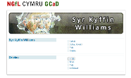 | Kyffin Williams was one of Wales’ most famous artists. This unit deals with his works in the Oriel Ynys Môn collection.  The purpose of the units is to introduce pupils to Kyffin Williams’ style, themes and techniques using tasks and information sheets. Due to Kyffin Williams’ fame much has been written about him including two autobiographies. This unit will be used to present some of the facts.  This unit can be used as a whole or suitable tasks may be selected for different classes. It contains individual, group and discussion tasks which cover the Key Stage 3 curriculum and aspects of the skills framework, developing communication, working with others and thinking skills.  The headings describe the nature of the tasks. It is also possible to use the collection of images as an additional stimulus with the whole class.  For further information read ‘Kyffin’ published by Oriel Ynys Môn (ISBN: 1-902565-09-6)
Title | Background
Activity  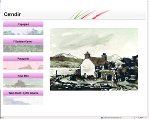 | This is a series of activities presenting the background to Kyffin Williams’ work. The resources are in five sections:  - Stimulus  - The Early Years  - Patagonia  - Ynys Môn  - Worksheet
Title | Work methods
Activity  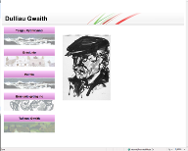 | This is a series of activities presenting Kyffin Williams’ work methods. The resources are in five sections:  - Initial tasks:  You can use a collection of images as a starting point for interpreting works or as a quick visual stimulus at the beginning of lessons, such as showing Kyffin Williams’ work on the interactive whiteboard with open or closed questions as a discussion stimulus.  - Sketching  - Painting  - Sketching with ink  - Worksheets
Title | People and Shapes
Activity | These two units look specifically at shapes and people. They include initial tasks, information worksheets, group work and individual drawing tasks.

Title | Galleries
Activity  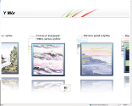 | There are four galleries which show a full gallery of Kyffin Williams’ pictures under four themes, namely:  - The Sea  - Landscape  - People  - Animals

